

SYMBIOSIS INTERNATIONAL (DEEMED UNIVERSITY)
(Established under section 3 of the UGC Act 1956)
Re-accredited by NAAC with “A” Grade

Name of the Student: Sneha Sah PRN: 25070122189
Semester: 3 Year: AY 25-29

ASSIGNMENT No: 4

TITLE: Develop a Java application demonstrating the use of wrapper classes for conversion between primitive data types and objects, and performing basic operations on wrapped values.

Problem Statement: Develop a Java application demonstrating the use of wrapper classes for conversion between primitive data types and objects, and performing basic operations on wrapped values.

Theory:
Wrapper classes are predefined classes that encapsulate primitive data types into objects. Java provides wrapper classes such as Integer, Double, Character, and Boolean for every primitive type. They support autoboxing, unboxing, parsing, and conversion methods. Wrapper classes are widely used in Java Collections Framework and when object representation of primitive values is required.

Exercise 1.
Create a program to convert student marks from String format to Integer and calculate total marks.

Source code:

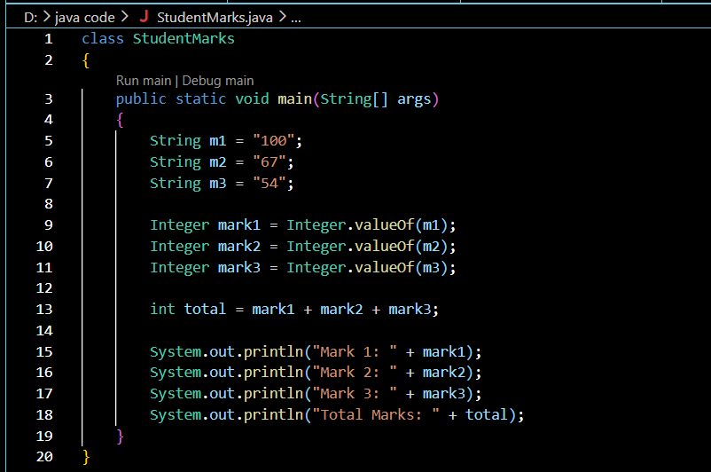

Output:

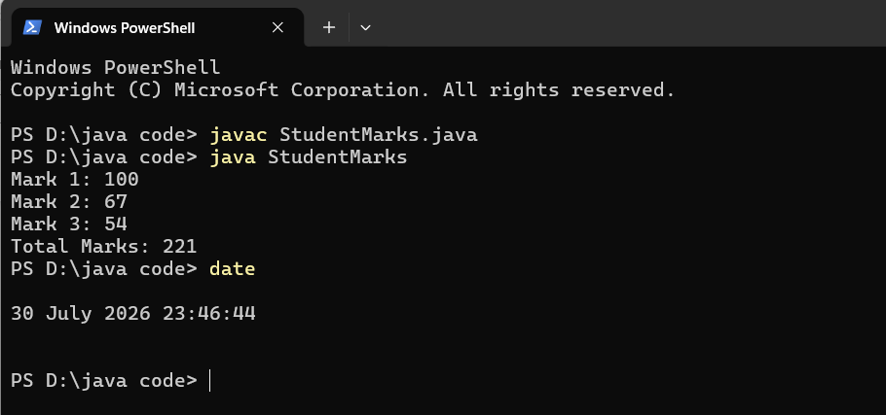

2. Develop an Employee Payroll System that accepts employee IDs, basic salary, and bonus amounts from the user. Convert the entered values into wrapper objects and perform validation operations to ensure valid salary values before calculating the net salary.

Source code:
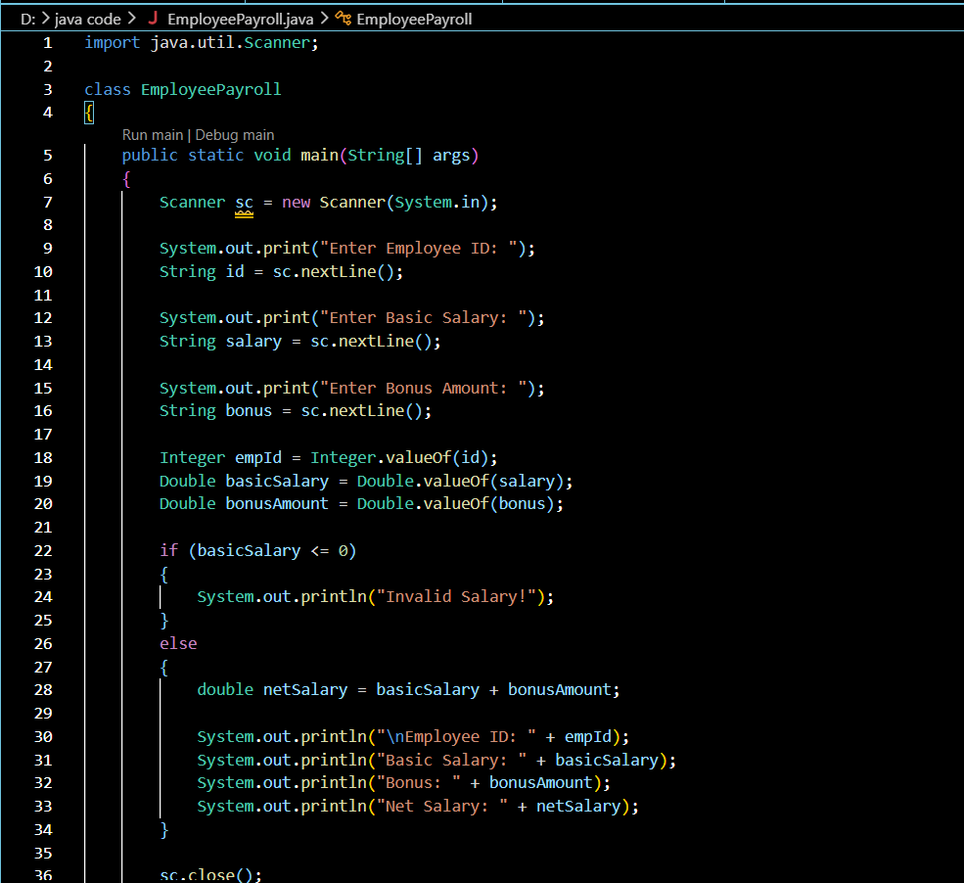
Output:
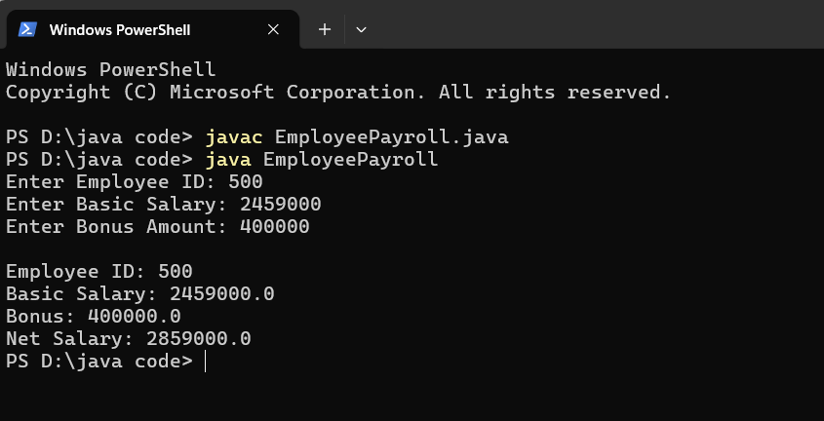
Conclusion:
The experiment successfully demonstrated the use of Wrapper Classes in Java for converting primitive data types into objects and objects back into primitive values. Classes such as Integer, Double, Character, and Boolean were used to understand the relationship between primitive data types and their corresponding wrapper objects.

The experiment also demonstrated important concepts such as autoboxing, unboxing, parsing, and conversion using methods like valueOf(). These concepts make it easier to handle input values, perform calculations, and validate data in Java programs. Overall, wrapper classes provide a useful way to work with primitive values as objects and are widely used in Java Collections Framework and object-oriented applications.

